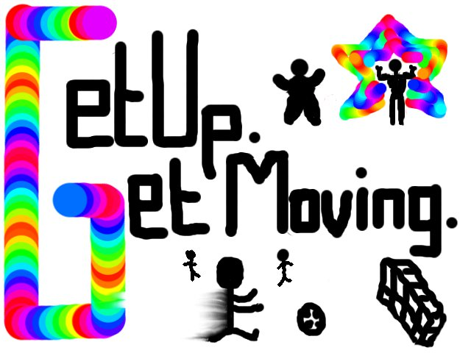
INFORMATION ABOUT INDIVIDUAL
Name: John Davis
Age: 16 years
Gender: Male
Occupation: Girl/Boy , Teens (11-17,Puberty)
Weight: 68.0 kg Weight: 150 pounds
Height: 1.6 m Height: 62.9 inches

You have a current BMI 26.7 .Viewing your BMI results you are overweight, and if you’re BMI go any higher you are at a risk. You will need to get him at a lower BMI ranging between 18.9 to 24-25.
I have used your current weight and height to indicate his current occupation to work out your suggested calorie intake each day which should be 2700 and your exercise time per week should be around 375 minutes.

The recommended fitness plan:
Your appropriate activity plan will include exercise every day, burning 1222 calories a week. These are the exercises you will experience during each week;
- Hiking
- Rugby – Youth
- Cricket
- Fencing
- Free weights
- Curling
- Fast walking

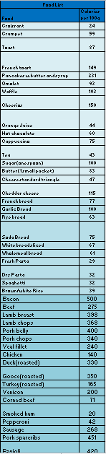
Meal time plans:
Your menu (over the 10 weeks) includes of many different foods, varying from breakfast, lunch and dinner. The spread sheet has 3 different pages, one of breakfast, lunch and dinner. On each page there is a food list which is colour coordinated in different shades of blue.
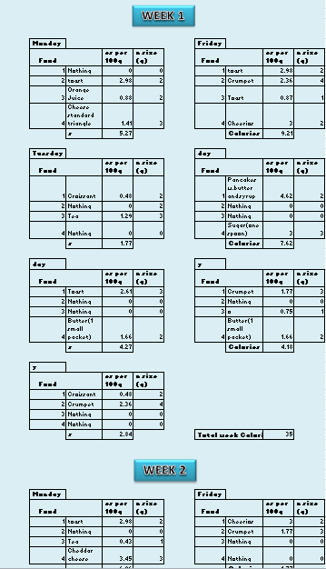

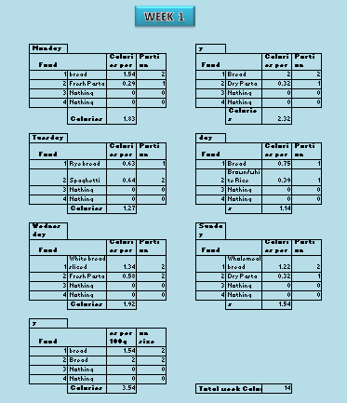

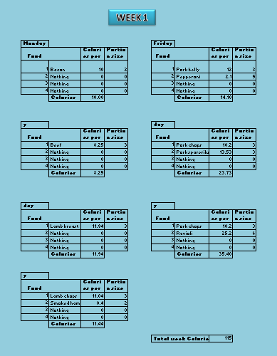

Charts
Imperial BMI Chart

Metric BMI Chart

Exercise chart

The above charts show that your BMI will decrease. The body is expected to adapt to the changes but overall it will be a loss in weight and BMI.

Conclusion
Following this plan will benefit your life by helping you lose weight as well as having a lower BMI, even though your body is over the ‘normal’ BMI level, you will be able to overcome that with a healthier/’normal’ weight – a smaller body mass index. Not only will you look 10 times better, you will also become fitter. Overall you will look and feel better. You will have a much more positive outlook on life. It will pay great bonuses for you down the road as far as your physical, emotional and mental state of mind.

